As Is Process Documentation
RetailEasy Pvt. Ltd.
Returns Process Automation | Prepared by: Pooja Suresh Chavan, Business Analyst | June 2026

- AS-IS PROCESS -NARRATIVE DESCRIPTION

Step I : Customer Sends Email
A customer who wishes to return an item sends a free-text email to support@retaileasy.in. There is no standard format, no form, and no guided experience. Emails range from detailed (with order IDs and photos) to vague ("I want to return something"). The email lands in a shared Gmail inbox monitored by 12 agents.
Pain Point : No standardized input — agents spend time extracting basic information that should be captured automatically.

Step II : Agents Reads Email (Next Available Agent)
An agent picks up the email — this could be the same day or the following morning depending on inbox volume. There is no assignment system, no SLA, and no priority flag. On peak days (post-sale events), emails can sit for 36–48 hours unread.
Pain Point: No structured queue or SLA — return requests have no guaranteed response time. Customers wait with zero acknowledgement.

Step III : Agent Requests Missing Information
The agent replies to the customer requesting: Order ID, photos of the item, and the reason for return. This is required in nearly every case because customers rarely include all three in their initial email. This creates an average delay of 12–24 hours per back-and-forth exchange.
Pain Point: 2–3 email round trips per return on average. Each trip adds a day to resolution time.

Step IV : Agent Checks Eligibility Manually
Once the agent has the order ID, they check a shared Google Sheet to verify: (a) whether the order is within the 7-day return window, and (b) the order value for refund eligibility. This sheet is manually updated and frequently out of date. Agents have been known to approve returns outside the return window due to incorrect delivery dates in the sheet.
Pain Point: Google Sheet is unreliable — stale data leads to incorrect approvals. No system enforcement of business rules.
Step V : Agent Notifies Warehouse via WhatsApp
If the return is approved, the agent sends a WhatsApp message to Sunita (Warehouse Lead) with partial details — usually just the order number and item type. There is no structured format, no ETA for the courier, and no confirmation mechanism. Sunita adds the return to her personal notebook.
Pain Point: Informal channel with no confirmation or record. Warehouse has no advance planning capability. Information is incomplete.

Step VI : Agent Manually Updates Finance Sheet
The agent is supposed to add a row to a separate Google Sheet shared with the Finance team, including the order ID, customer name, refund amount, and approval date. This step is frequently forgotten or delayed, especially during high-volume periods.

Pain Point: Manual hand-off to finance is unreliable. Missing or duplicate entries cause incorrect refund processing.

Step VII — Customer Ships Item Back
The customer arranges their own courier to ship the item back. There is no return shipping label provided, no standard courier, and no tracking mechanism. Customers use whatever courier they choose, often at their own cost, with no visibility to the RetailEasy team.
Pain Point: No standardized return shipping — RetailEasy cannot track incoming items, and customers bear courier cost and burden.

Step VIII — Warehouse Receives Item
The item arrives at the warehouse, often unannounced. Sunita or a warehouse team member physically receives it and checks it against the notebook entry. If the volume is high and no one is stationed at the receiving bay, items may wait hours before being logged.
Pain Point: Unplanned arrivals with no pre-notification — warehouse cannot allocate staff. Receipt confirmation is manual and slow.

Step IX — Warehouse Confirms Receipt via WhatsApp
Sunita sends a WhatsApp message to Rahul confirming the item was received. Rahul then notifies Amit in the Finance team either via email or by updating the Google Sheet (if he remembers). There is no systematic trigger.
Pain Point: Multi-step manual chain to trigger refund — every step is an opportunity for delay, omission, or error.

Step X — Finance Processes Refund Manually
Amit checks the Finance Google Sheet in the afternoon and manually processes eligible refunds through the payment gateway portal. He processes in batch, meaning a return confirmed at 9 AM might not be refunded until 4–5 PM or even the following day.
Pain Point: Batch processing introduces 4–24 hour delays on top of an already slow process. No customer notification of refund trigger.

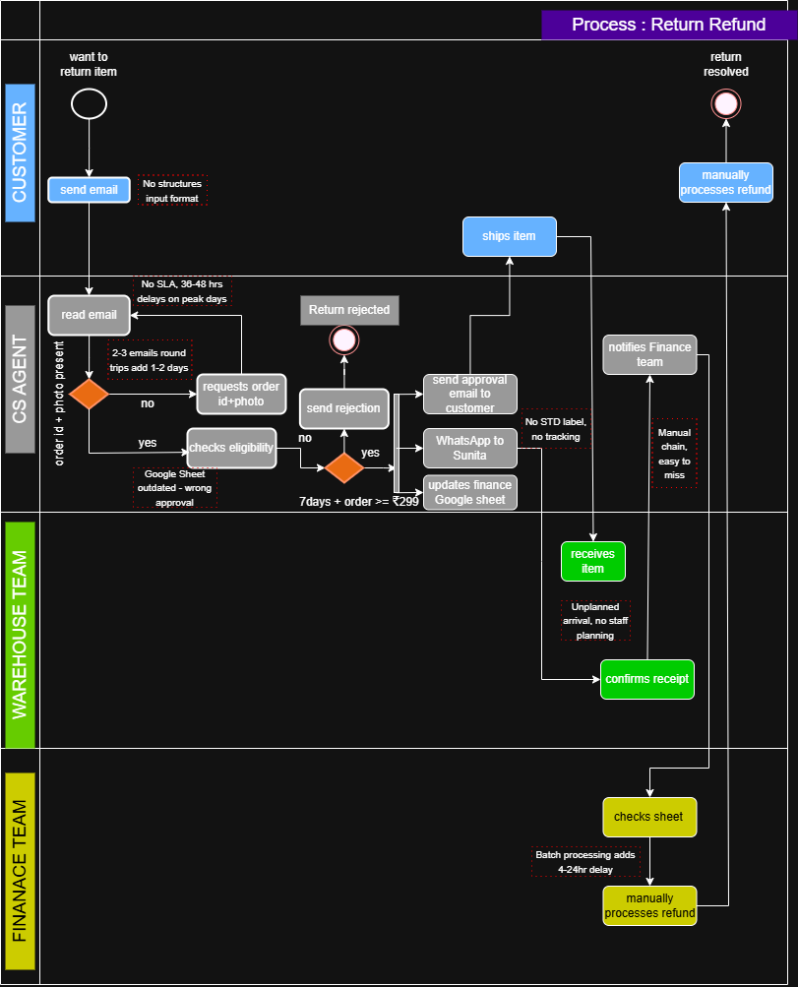

Symbol
○ | Start Event
◎ | End Event
▢ | Task/Activity
◇ | Exclusive Gateway/ Decision
→ | Sequence Flow
║ | Fork/Split
…….  . .  . .  ……. | Issue/Pain Point

Note:
Process Modelling Standard : The process has been modelled using BPMN 2.0 notation with swimlanes representing Customer, Customer Service Agent, Warehouse Team, and Finance Team responsibility.

